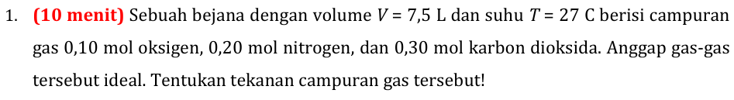
Diketahui:
$$V=7,5 L$$
$$T=27 C=300 K$$
$$n1=0,1$$
$$n2=0,2$$
$$n3=0,3$$
Anggap Gas Ideal.
Ditanya:
$$P_{tot}=?$$

Rumus gas ideal:
$$PV=nRT$$
$$R=0,082\frac{L atm}{mol K}$$
Dicari P:
$$P=\frac{nRT}{V}$$
Mencari n total:
$$n_{tot}=n1+n2+n3$$
$$n_{tot}=0,1+0,2+0,3$$
$$n_{tot}=0,6$$
Mencari jawaban P:
$$P=0,6×0,082×300=1,968 atm.$$

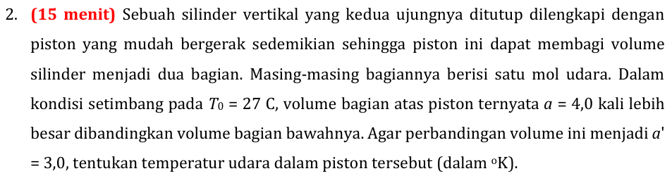

Keadaan 1:
Diketahui:
$$n_{a}=n_{b}=1$$
$$T_{0}=27 C=300K$$
$$\frac{V_{a}}{V_{b}}=\frac{4}{1}$$
Ditanya:
$$jika\frac{V_{a}}{V_{b}}=\frac{3}{1}$$
$$T^{'}=?$$

Rasio V:
$$V=V_{a}+V_{b}$$
$$5=4+1$$
$$V_{a}=\frac{4}{5}V$$
$$V_{b}=\frac{1}{5}V$$
Kesetimbangan: (gas ideal)
$$P_{a}V_{a}=nRT$$
$$P_{b}V_{b}=nRT$$
$$P_{a}V_{a}=P_{b}V_{b}$$
$$P_{a}\frac{4}{5}V=P_{b}\frac{1}{5}V$$
$$4P_{a}=P_{b}$$
Identifikasi tekanan:
$$P_{b}=P_{a}+P_{p}$$
$$4P_{a}=P_{a}+P_{p}$$
$$P_{p}=3P_{a}$$
Menurunkan Pa:
$$P_{a}V_{a}=nRT$$
$$P_{a}=\frac{nRT}{V_{a}}$$
Memasukkan nilai Pa:
$$P_{p}=\frac{3nRT}{V_{a}}$$
$$P_{p}=\frac{3nRT}{\frac{4}{5}V}$$
$$P_{p}=\frac{1125R}{V}$$

Keadaan 2
Rasio volume:
$$\frac{V_{a}^{'}}{V_{b}^{'}}=\frac{3}{1}$$
$$V={V'}_{a}+{V'}_{b}$$
$$V_{a}^{'}=\frac{3}{4}V$$
$$V_{b}^{'}=\frac{1}{4}V$$
Kesetimbangan:
$$P_{a}^{'}V_{a}^{'}=P_{b}^{'}V_{b}^{'}$$
$$P_{a}^{'}\frac{3}{4}V=P_{b}^{'}\frac{1}{4}V$$
$$3P_{a}^{'}=P_{b}^{'}$$
Analisis tekanan system:
$$P_{b}^{'}=P_{a}^{'}+P_{p}$$
$$3P_{a}^{'}=P_{a}^{'}+\frac{1125R}{V}$$
$$2P_{a}^{'}=\frac{1125R}{V}$$
Mencari nilai P’a:
$$PV=nRT$$
$$P_{a}^{'}=\frac{nRT'}{V_{a}^{'}}$$
Masukkan nilai P’a:
$$2\frac{nRT'}{V_{a}^{'}}=\frac{1125R}{V}$$
$$2\frac{nRT'}{\frac{3}{4}V}=\frac{1125R}{V}$$
$$T^{'}=421,87 K$$
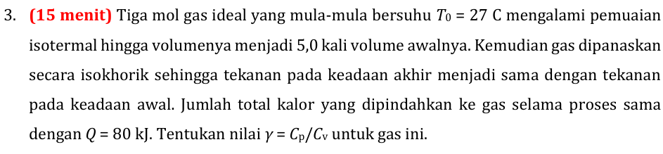

Diketahui:
$$T_{0}=27 C=300 K$$
- Isotermal: ($ΔT=0$)
$$V_{b}=5V_{a}$$

- Isokhoris: ($ΔV=0$)
$$P_{c}=P_{a}$$

Ditanya:
$$γ=\frac{C_{p}}{C_{v}}=?$$
$$Cp=Cv+R$$

Analisis proses isothermal: (A ke B)
$$ΔT=0$$
Pers. Gas ideal:
$$P_{a}V_{a}=nRT$$
$$P_{b}V_{b}=nRT$$
$$P_{a}V_{a}=P_{b}V_{b}$$
$$P_{a}V_{a}=P_{b}5V_{a}$$
$$P_{a}={5P}_{b}…….(1)$$
Mencari W (usaha) dari A ke B:
$$W=nRTln(V_{b}/V_{a})$$
$$W=nRTln\left(5\right)$$
$$W=3.8,314.300.\ln\left(5\right)$$
$$W=12042,78 J……….\left(2\right)$$
Mencari Q dari A ke B:
$$Q=ΔU+W$$
$$ΔU=n.C_{v}.ΔT$$
$$Q=W$$
$$Q=12042,78 J$$

Isokhoris:
$$ΔV=0$$
Mencari Q isokhoris:
$$Q_{tot}=Q_{isokhoris}+Q_{isotermal}$$
$$80000=Q_{isokhoris}+12042,78$$
$$Q_{isokhoris}=67957,22J$$
Persamaan gas ideal:
$$P_{b}V=nRT_{b}$$
$$P_{c}V=nRT_{c}$$
$$\frac{P_{b}}{T_{b}}=\frac{P_{c}}{T_{c}}$$
$$\frac{P_{b}}{T_{b}}=\frac{P_{a}}{T_{c}}$$
Masukan persamaan 1:
$$\frac{P_{b}}{T_{b}}=\frac{5P_{b}}{T_{c}}$$
$$T_{c}=5T_{b}$$
$$T_{b}=T_{a}=300K$$
$$T_{c}=5T_{a}=5.300=1500K$$

Mencari Cv:
$$Q_{isokhoris}=ΔU+W; W=0$$
$$Q_{isokhoris}=ΔU$$
Mencari delta U:
$$ΔU=n.C_{v}.\left(T_{c}-T_{b}\right)$$
$$67957,22=3.C_{v}.(1500-300)$$
$$C_{v}=18,88$$
Mencari Gamma:
$$γ=\frac{C_{p}}{C_{v}};C_{p}=C_{v}+R$$
$$γ=\frac{C_{v}+R}{C_{v}}$$
$$γ=1,44$$

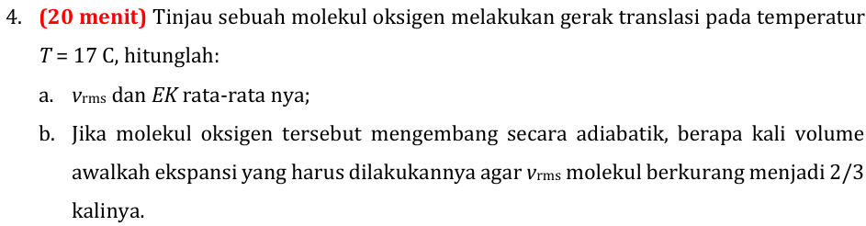
Teori Ekipartisi:

Diketahui:
$$T=17C=290 K$$
$$n=1$$
- Tinjau energi dalam (U):
$$U=\frac{3}{2}kT$$
$$Sumbu x=\frac{1}{2}kT;sumbu y=\frac{1}{2}kT;sumbu z=\frac{1}{2}kT$$

Tinjau energi kinetic rata2(partikel):
$$Ek=\frac{1}{2}m_{0}v_{rms}^{2}$$
Hubungkan energi dalam dan energi rata2:
$$\frac{1}{2}m_{0}v_{rms}^{2}=\frac{3}{2}kT$$
$$v_{rms}=\sqrt{\frac{3kT}{m_{0}}}$$
Mencari massa partikel mo:
$$m=m_{0}N_{A};N_{A}=6,022×{10}^{26}partikel$$
$$m_{0}=\frac{m}{N_{A}}=n\frac{Mr}{N_{A}}=5,31×{10}^{-26}kg$$
Masukkan nilai mo ke v rms:
$$v_{rms}=\sqrt{\frac{3kT}{m_{0}}}$$
$$v_{rms}=\sqrt{\frac{3. 1,38×{10}^{-23}.290}{5,31×{10}^{-26}}}=475,25\frac{m}{s}$$
Mencari Ek rata2:
$$Ek=\frac{1}{2}m_{0}v_{rms}^{2}$$
$$Ek=\frac{1}{2}.5,31×{10}^{-26}.475,25=5,997×{10}^{-21}J.$$

B.
Adiabatis:
$$P_{1}V_{1}^{γ}=P_{2}V_{2}^{γ}$$
Persamaan gas ideal:
$$P_{1}=\frac{nRT_{1}}{V_{1}}$$
$$P_{2}=\frac{nRT_{2}}{V_{2}}$$
Masukkan pers. Gas ideal ke adiabatis:
$$\frac{nRT_{1}}{V_{1}}V_{1}^{γ}=\frac{nRT_{2}}{V_{2}}V_{2}^{γ}$$
$$T_{1}V_{1}^{γ-1}=T_{2}V_{2}^{γ-1}$$
$$\frac{T_{1}}{T_{2}}=\frac{V_{2}^{γ-1}}{V_{1}^{γ-1}}$$

Mencari T dari pers. V rms:
$$v_{rms}=\sqrt{\frac{3kT}{m_{0}}}$$
$$v_rms∝\sqrt{T}$$

Yg kita acari:
$$\sqrt{\frac{T_{1}}{T_{2}}}=\frac{v_{rms1}}{v_{rms2}}$$
$$T_{1}/T_{2}=\frac{v_{rms1}^{2}}{v_{rms2}^{2}}$$
$$\frac{v_{rms1}^{2}}{v_{rms2}^{2}}=\frac{3^{2}}{2^{2}}=\frac{9}{4}$$
Masukkan nilai T ke persamaan adiabatis:
$$\frac{9}{4}=\frac{V_{2}^{γ-1}}{V_{1}^{γ-1}}; γ=1,4$$
Mencari perbandingan V:
$$\frac{V_{2}}{V_{1}}=7,6$$

